Homework FOUR

CMIS 141 Intro to Programming

Steven Thaw

Abstract

This project creates a program that allows a user to enter state names which are case insensitive and return the state, state song, and state bird.



|  |  |  |  |
| --- | --- | --- | --- |
| Test Case | Input | Expected Output | Pass or Fail |
| 1 | maryland, FLORIDA, new York, none | Welcome to the States Program, where you can easily findyour favorite State's bird and song!  Please enter a State to research (enter none to complete): maryland  Selected State: Maryland. Bird: Baltimore oriole. Song: "Maryland, My Maryland".  Please enter a State to research (enter none to complete): FLORIDA  Selected State: Florida. Bird: Northern mockingbird. Song: "Old Folks at Home (Swanee River)".  Please enter a State to research (enter none to complete): new York  Selected State: New York. Bird: Eastern bluebird. Song: "I Love New York".  Please enter a State to research (enter none to complete): none  Thanks for using our program. Here are your results:  Maryland, Baltimore oriole, "Maryland, My Maryland", Florida, Northern mockingbird, "Old Folks at Home (Swanee River)", New York, Eastern bluebird, "I Love New York", | Pass |
| 2 | North carolina, hawaii, new hampshire, coloraDo, NONE | Welcome to the States Program, where you can easily findyour favorite State's bird and song!  Please enter a State to research (enter none to complete): North carolina  Selected State: North Carolina. Bird: Northern cardinal. Song: "The Old North State".  Please enter a State to research (enter none to complete): hawaii  Selected State: Hawaii. Bird: Hawaiian goose (Nēnē). Song: "Hawaiʻi Ponoʻī".  Please enter a State to research (enter none to complete): new hampshire  Selected State: New Hampshire. Bird: Purple finch. Song: "Old New Hampshire".  Please enter a State to research (enter none to complete): coloraDo  Selected State: Colorado. Bird: Lark bunting. Song: "Where the Columbines Grow".  Please enter a State to research (enter none to complete): NONE  Thanks for using our program. Here are your results:  North Carolina, Northern cardinal, "The Old North State", Hawaii, Hawaiian goose (Nēnē), "Hawaiʻi Ponoʻī", New Hampshire, Purple finch, "Old New Hampshire", Colorado, Lark bunting, "Where the Columbines Grow", | Pass |
| 3 | New jersey, california, north dakota, maInE, WAShington, NEW mexico, NoNe | Welcome to the States Program, where you can easily findyour favorite State's bird and song!  Please enter a State to research (enter none to complete): New jersey  Selected State: New Jersey. Bird: Eastern goldfinch. Song: None.  Please enter a State to research (enter none to complete): california  Selected State: California. Bird: California quail. Song: "I Love You, California".  Please enter a State to research (enter none to complete): north dakota  Selected State: North Dakota. Bird: Western meadowlark. Song: "North Dakota Hymn".  Please enter a State to research (enter none to complete): maInE  Selected State: Maine. Bird: Chickadee. Song: "State of Maine Song".  Please enter a State to research (enter none to complete): WAShington  Selected State: Washington. Bird: Willow goldfinch. Song: "Washington, My Home".  Please enter a State to research (enter none to complete): NEW mexico  Selected State: New Mexico. Bird: Roadrunner. Song: "O Fair New Mexico".  Please enter a State to research (enter none to complete): NoNe  Thanks for using our program. Here are your results:  New Jersey, Eastern goldfinch, None, California, California quail, "I Love You, California", North Dakota, Western meadowlark, "North Dakota Hymn", Maine, Chickadee, "State of Maine Song", Washington, Willow goldfinch, "Washington, My Home", New Mexico, Roadrunner, "O Fair New Mexico", | Pass |

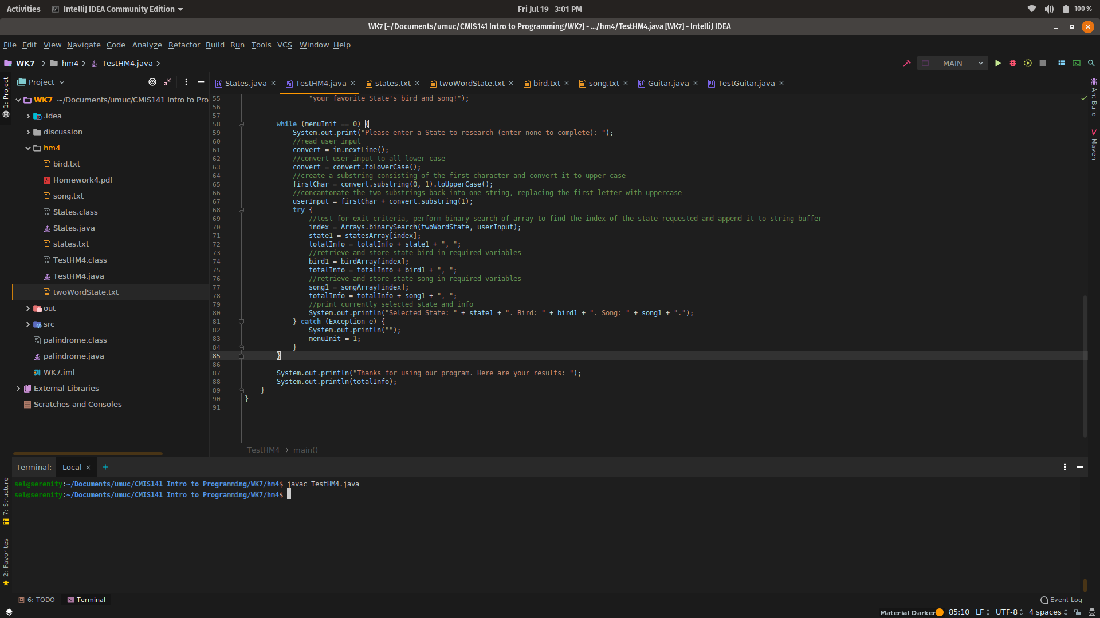  
Figure 1: Compilation of Program

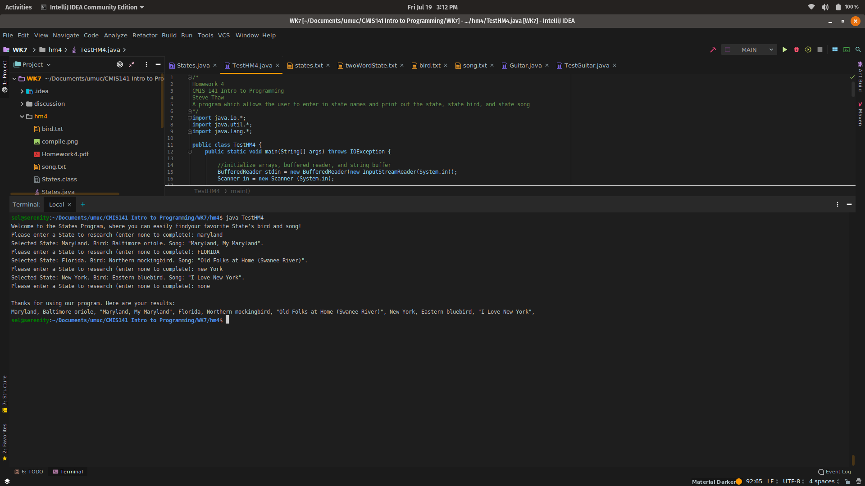  
Figure 2: Execution of 1st Test Case

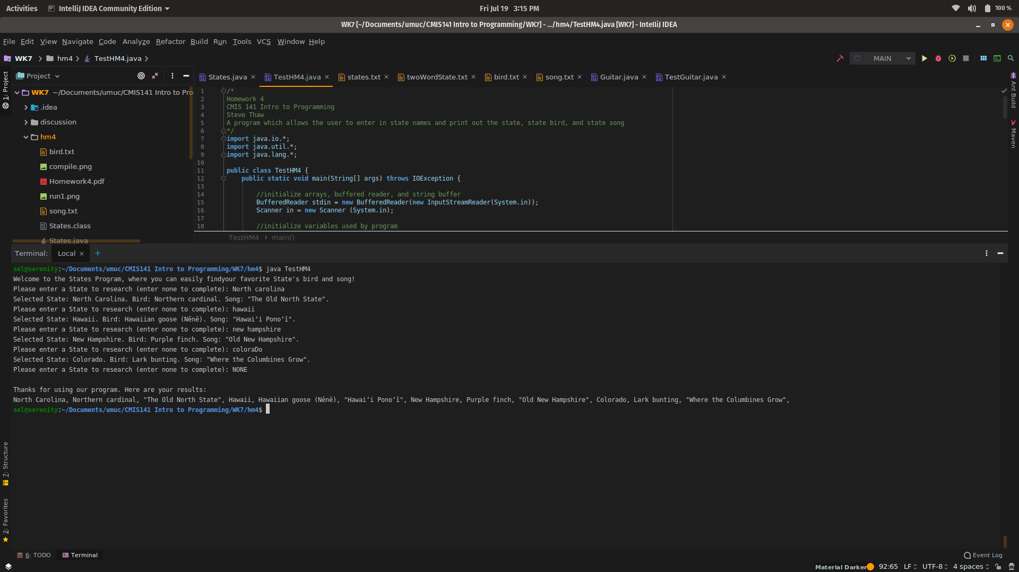  
Figure 3: Execution of 2nd Test Case

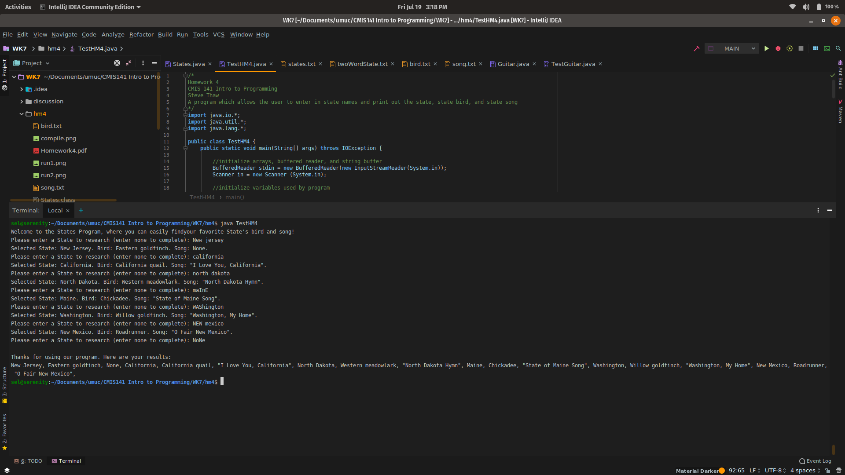  
Figure 4: Execution of 3rd Test Case